Nama : Muchammad Daniyal Kautsar

NIM : 21/479067/TK/52800

NIU : 479067

Prodi : Teknologi Informasi

Quiz Himpunan Matematika Diskret

1. Misalkan A = {b, c, d, f, g}, dan B = {a, b,c}. Tentukan
2. A ∪ B

* A ∪ B = {a, b, c, d, f, g}

1. A ∩ B

* A ∩ B = {b, c}

1. A – B

* A – B = {d, f, g}

1. B – A

* B – A = {a}

1. Misalkan A = {1,2} dan B = {2,3}. Tentukan
2. P(A ∩ B)

* A ∩ B = {2}
* P(A ∩ B) = {∅, {2}}

1. P(A)

* P(A) = {∅, {1}, {2}, {1, 2}}

1. P(A ∪ B)

* A ∪ B = {1, 2, 3}
* P(A ∪ B) = {∅, {1}, {2}, {3}, {1, 2}, {1,3}, {2, 3}, {1, 2, 3})

1. P(A x B)

* A x B = {{1, 2}, {1,3}, {2,2}, {2, 3}}
* P(A x B) = **{**∅, {(1, 2)}, {(1, 3)}, {(2, 2)}, {(2, 3)}, {(1, 2), (1, 3)}, {(1, 2), (2, 2)}, {(1, 2), (2, 3)},{(1, 3), (2, 2)}, {(1, 3), (2, 3)}, {(2, 2), (2, 3)}, {(1, 2), (1, 3), (2, 2)}, {(1, 2), (1,3), (2, 3)}, {(1, 2), (2, 2), (2, 3)}, {(1, 3), (2, 2), (2, 3)}, {(1, 2), (1, 3), (2, 2), (2, 3)} **}**

1. Misalkan A dan B adalah dua himpunan. Buktikan bahwa

(A – B) ∩ (A ∩ B) = ∅

* Misalkan diketahui himpunan A dan himpunan B dengan anggotanya masing-masing dan dikenai operasi (A – B) dan (A ∩ B) dengan diagram venn sebagai berikut

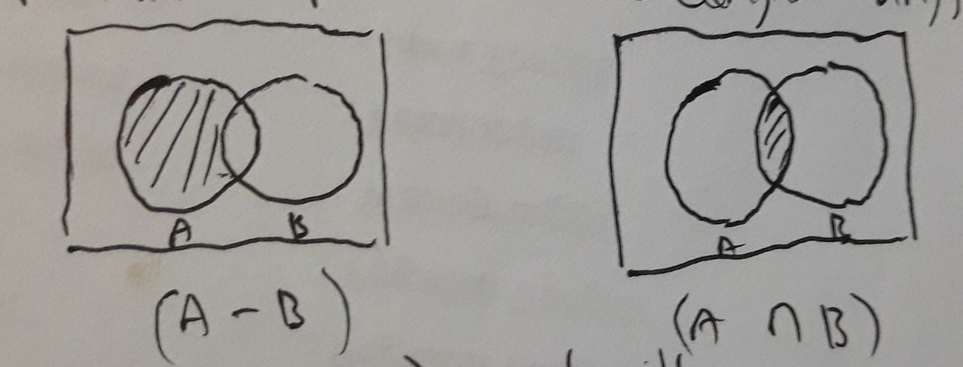

Maka, (A – B) = A – (A ∩ B) sehingga operasi (A – B) ∩ (A ∩ B) dapat berubah bentuk menjadi

(A – B) ∩ (A ∩ B) = (A– (A ∩ B)) ∩ (A ∩ B)

= (A ∩ (A ∩ B)) – ((A ∩ B) ∩ (A ∩ B))

= (A ∩ B) – (A ∩ B)

= ∅

Jadi, operasi (A – B) ∩ (A ∩ B) menghasilkan himpunan kosong (∅).